1. What are the key guidelines to follow before using the ViBe platform? 2
2. What are the technical requirements for using the ViBe platform? 2
3. How do I log in to the ViBe platform? 3
4. I cannot find my course on the dashboard. What can I do? 9
5. Videos are not playing / stuck on repeat. 10
6. I am getting an “Access Restricted” error. 10
7. My quiz answers are correct, but the system is marking them wrong. 11
8. How do I get my certificate? 11
9. I missed completing the course within the deadline. What should I do? 11
10. Whom should I contact for technical issues? 11
11. Can we use Mobile or tablet to access the program? 12
12. What is the last date for completion of all ViBe activity? 12
13. ViBe is not detecting my face, what should I do? 12
14. Why can’t I log in or access the ViBe? 12
15. Why does the system show “Access Restricted” and “Quiz Passed – No Available Attempts” after I submit my quiz? 13
16. Why do my videos auto-restarts? 13
17. Why is the quiz not opening even after completing the video segment? 14

1. What are the key guidelines to follow before using the ViBe platform?
- Sit in a well lit environment.
- Keep your face uncovered at all times.
- Ensure the background is clear and not blurred.
- Position the camera to capture your entire face.
- Avoid lighting that causes glare or shadow on your face.
- Confirm that your camera is switched on and has the necessary permissions.
- Sit in a quiet place to avoid disturbances.Ensure no one else is visible in the camera frame.

2. What are the technical requirements for using the ViBe platform?

To ensure a smooth experience on the ViBe platform, please follow the recommended system requirements:
- Device Compatibility
  - ViBe can be accessed only on laptops or desktops with proper mic and camera access.
  - Mobile phones and tablets are not supported.
- Browser Requirement
  - Use Google Chrome (Version 142.0.7444.163, 64-bit) or above.
- Operating System
  - Windows 7 is acceptable, but Windows 10 or later is strongly recommended for optimal performance.
- System Specifications
  - Processor: Intel Core i3 or better.
  - RAM: Minimum 8 GB
- Internet Connectivity
  - 5G networks or high-speed stable broadband is recommended.

3. How do I log in to the ViBe platform?
Step 1: First, copy the course registration link shared in the “ Welcome mail” you received through MMTTP ID and open it in the Chrome browser.
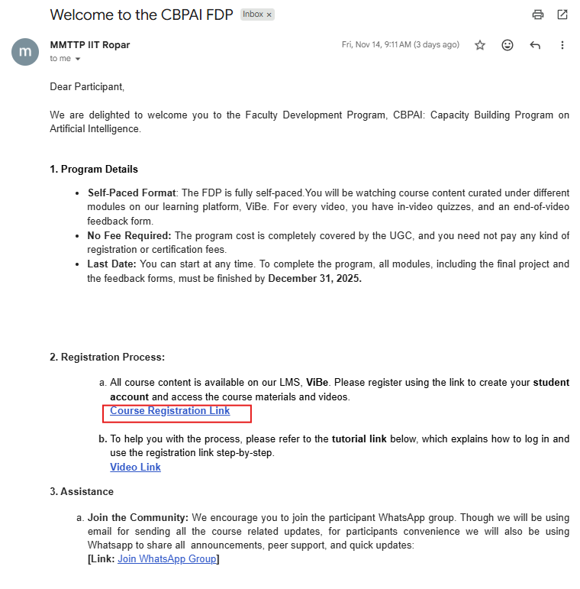

Step 2: Log in to the ViBe platform as a student.
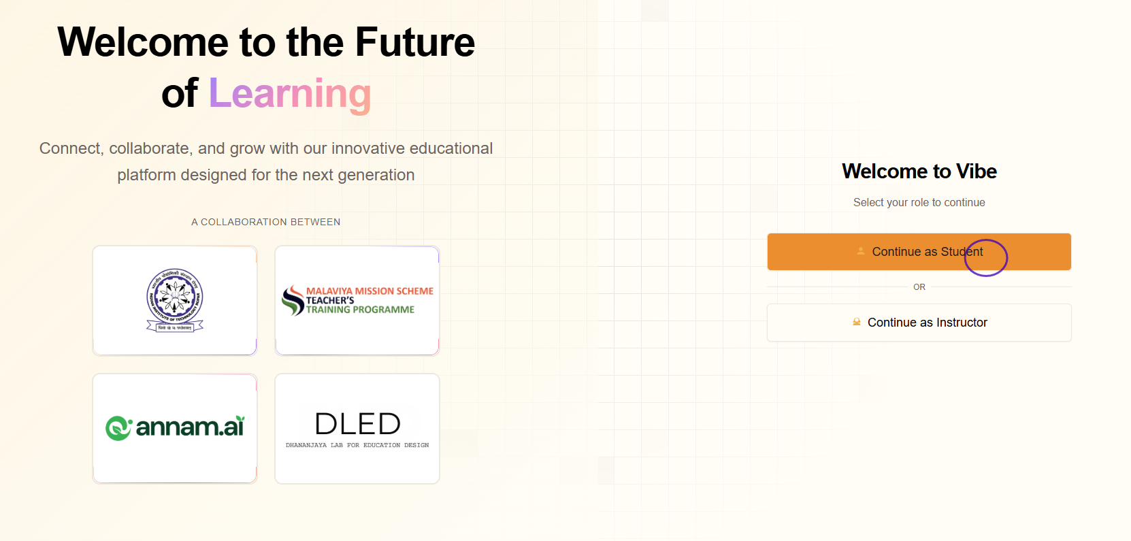
Step 3: Use Sign in with Google to avoid creating or remembering extra passwords.

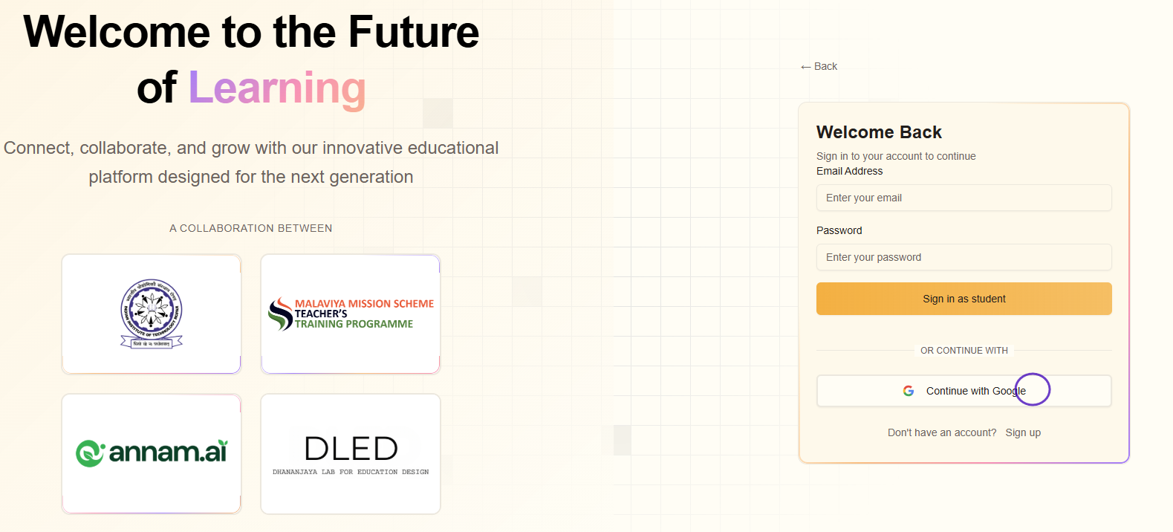

Step 4: This will take you to the ViBe Dashboard.
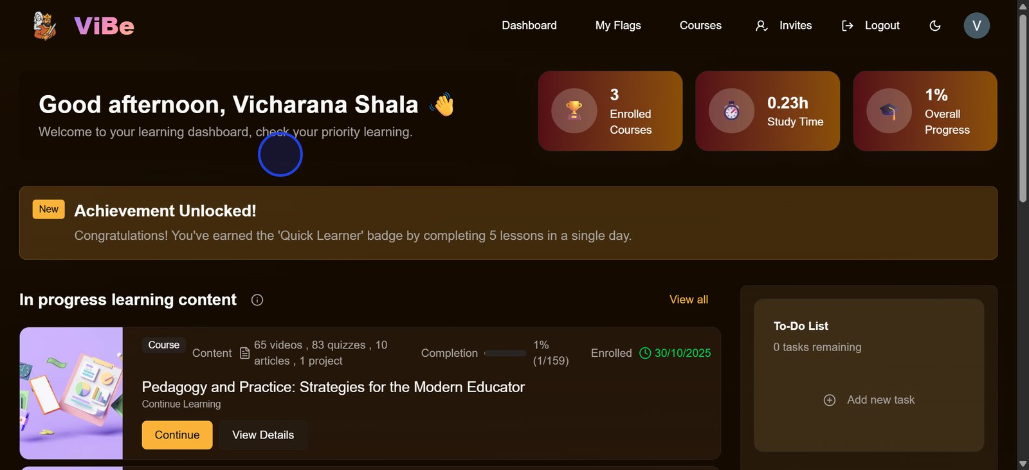

Step 5: Once you reach your dashboard, paste the registration link into the Google Chrome address bar.
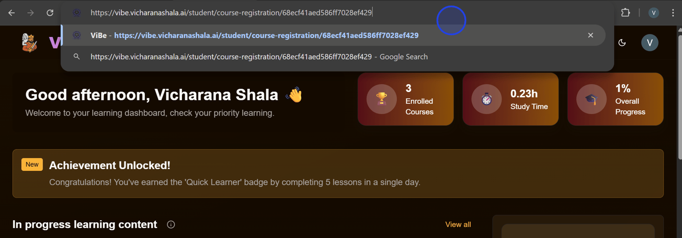

Step 6: This will open the course registration form.
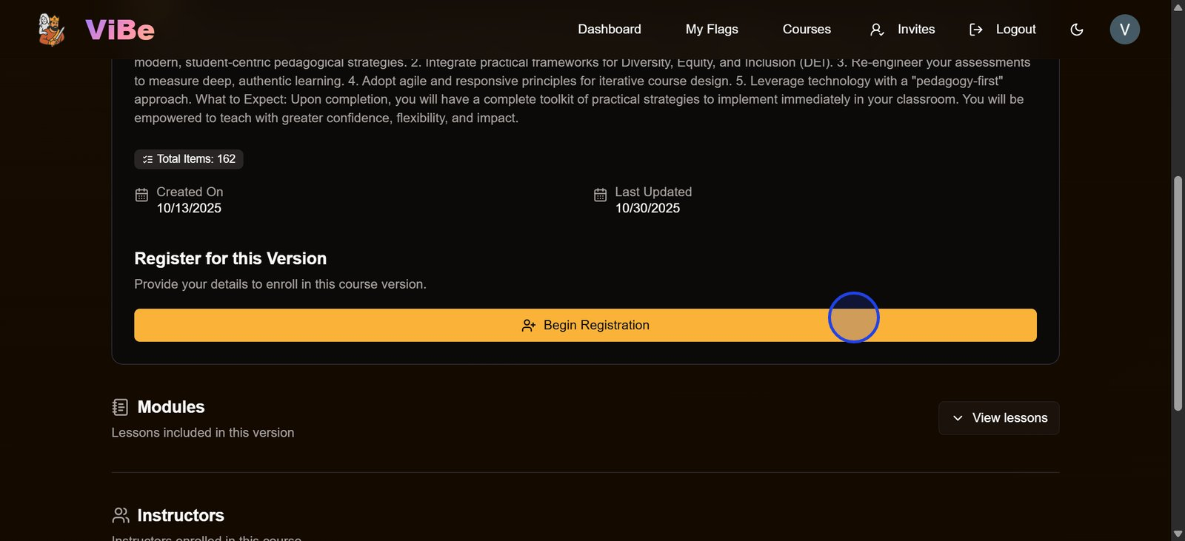
Step 7: Fill in all the required details such as name, email ID, registration number, and any other information asked.
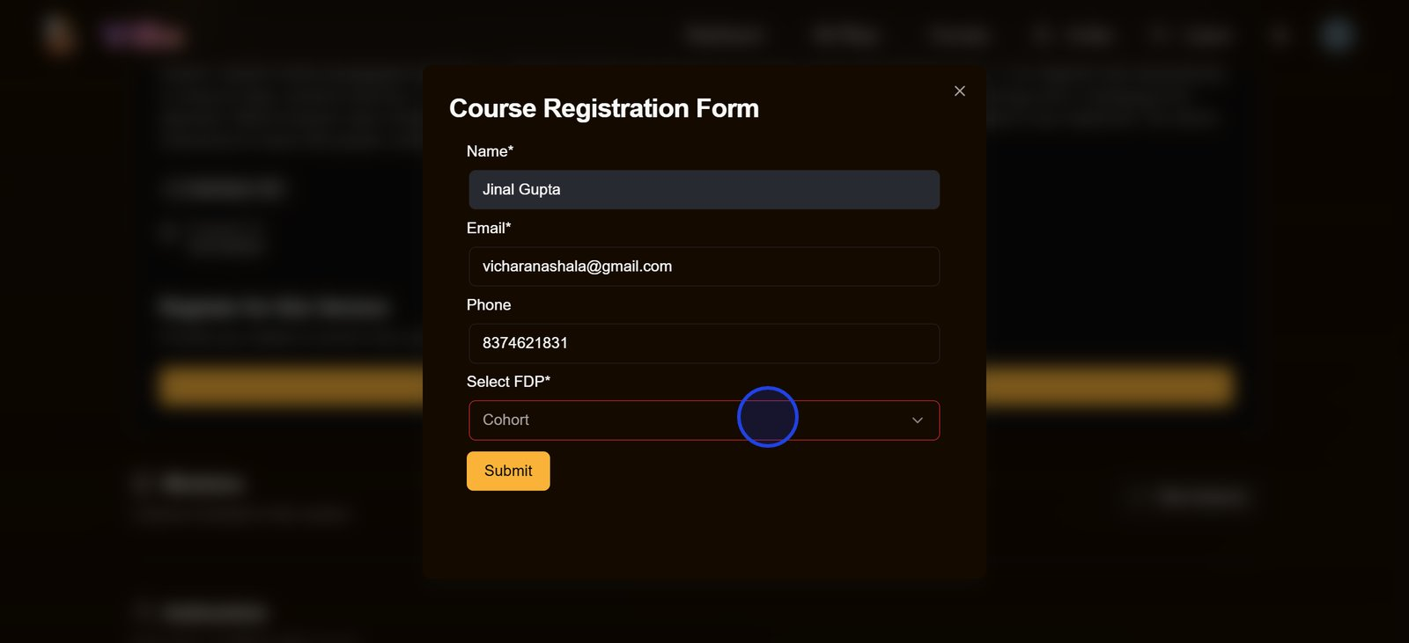
Step 8: Submit the form to send your enrollment request to the instructor.
Step 9:Wait for the instructor to verify and approve your request.

Step 10: Once the instructor approves your request, you will receive a confirmation email in your registered ID mail.
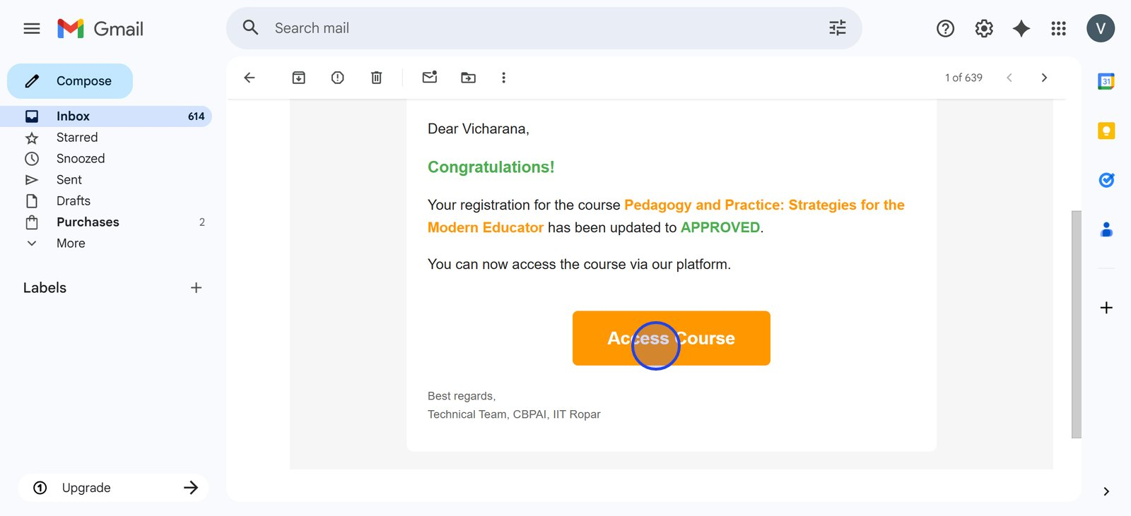
Step 11: As soon as you click on the access course option, the course will be visible on your dashboard.
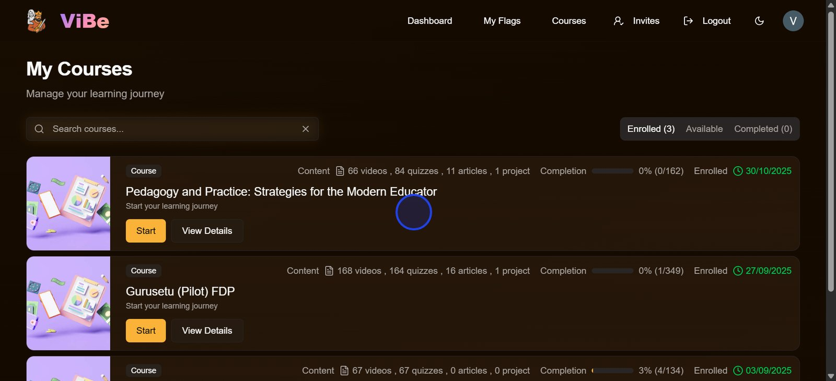

Step 12: Accept all the declarations shown on the ViBe platform and start with your course, following the above given key guidelines.
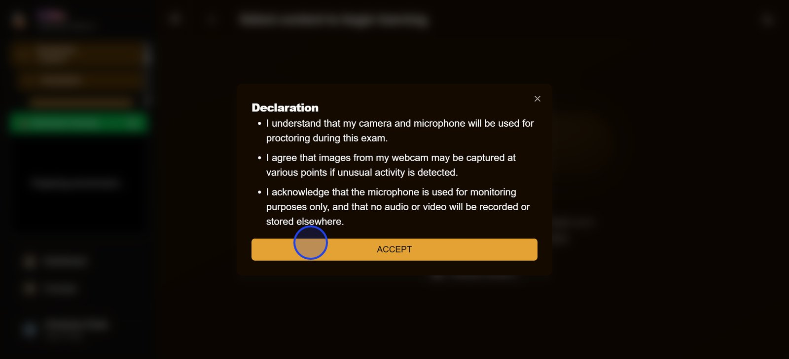

4. I cannot find my course on the dashboard. What can I do?
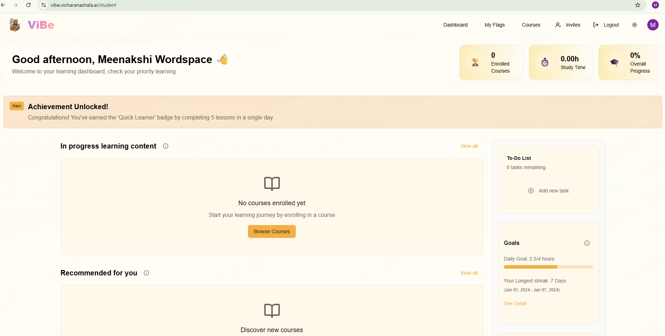
If you face this issue, try these steps:
Step 1:Copy the same “ Course registration link” shared in the “ Welcome mail” and paste it in the Google Chrome search bar.

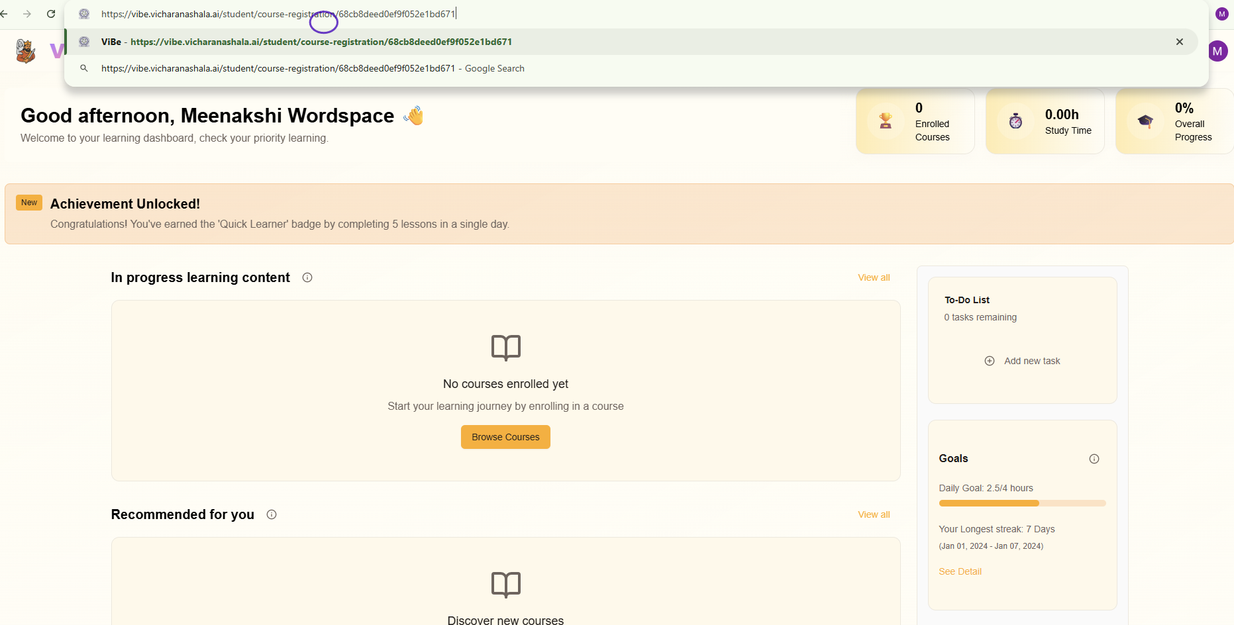
( Or)
Step 2:Your details are currently under verification, and the instructor’s approval is still pending.
Please wait for some time. Once your information is verified and approved, the course will automatically appear on your dashboard.

—

5. Videos are not playing / stuck on repeat.
Step 1: Make sure you are watching the videos in sequential order without skipping.
Step 2: Allow camera and microphone access (mandatory for progress tracking).
Step 3: Clear your browser cache and cookies, then refresh with Ctrl + Shift + R.

—

6. I am getting an “Access Restricted” error.
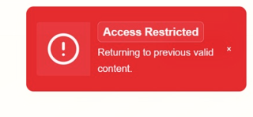
This usually happens if a step is skipped.
Step 1: Please watch each video in order.
Step 2: If it still persists, try refreshing the page by pressing Ctrl + R. You may be redirected to the dashboard, but don’t worry—you can easily return to your course and continue from where you left off.

—

7. My quiz answers are correct, but the system is marking them wrong.
Step 1: Please note the video number and case study name.
Step 2: Report it to the support desk, email ID support-cbpai@vicharanashala.zohodesk.in.
Step 3: In some cases, the issue is resolved from the backend within a few hours.
—

8. How do I get my certificate?
Step 1: Certificates are issued only if all requirements are completed (100% videos, quizzes, assignments, polls, and project components if applicable).
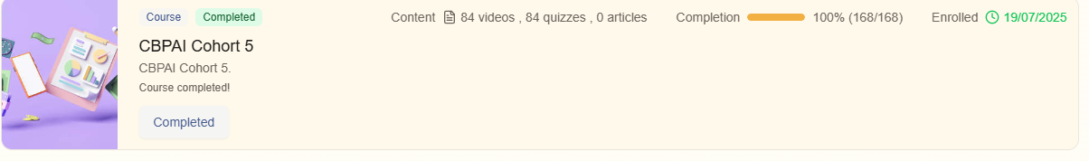
Step 2: Certificates are compiled after verification.
Step 3: Then send your registered email.
—

9. I missed completing the course within the deadline. What should I do?
If you could not finish before the deadline, you will need to register again for the next cohort.
—

10. Whom should I contact for technical issues?
Please share a screenshot or screen recording of the issue along with your registered email ID. You can send this either to the support desk email as: support-cbpai@vicharanashala.zohodesk.in
or in the WhatsApp group.
While reporting, kindly include the following details:
- Your full name
- Your registered email ID
- The Complete FDP name.
Providing these details will help our support team resolve your issue more quickly and efficiently.
—

11. Can we use Mobile or tablet to access the program?
The software cannot be accessed using a mobile phone or tablet. Please ensure you are using a desktop, PC, or laptop with an active camera and microphone.
—

12. What is the last date for completion of all ViBe activity?
All ViBe-related activities and assignments to be completed by a deadline which will be mentioned in your welcome mail.
—

13. ViBe is not detecting my face, what should I do?
To ensure your face is properly detected by the software, please follow these guidelines:
- Sit in a well-lit room.
- Keep your face uncovered at all times.
- Ensure the background is clear and not blurred.
- Position the camera to capture your entire face.
- Avoid lighting that causes glare or shadow on your face.
- Confirm that your camera is switched on and has the necessary permissions.
- Sit in a quiet place to avoid disturbances.
- Ensure no one else is visible in the camera frame.
—

14. Why can’t I log in or access the ViBe?
Step 1: Ensure that you have pasted the correct “ course registration link”sent in the welcome mail to your registered email ID.
Step 2: Ensure that you log in “ as a student” in the ViBe platform.
Step 3: If it still doesn’t work then refresh the page by pressing Ctrl + R or clear the cache by pressing Ctrl + Shift + R.
Step 4:If the issue persists, please contact our support desk via email or message, providing your name, registered email ID, and either a screenshot or a screen recording of the problem.
__

15. Why does the system show “Access Restricted” and “Quiz Passed – No Available Attempts” after I submit my quiz?
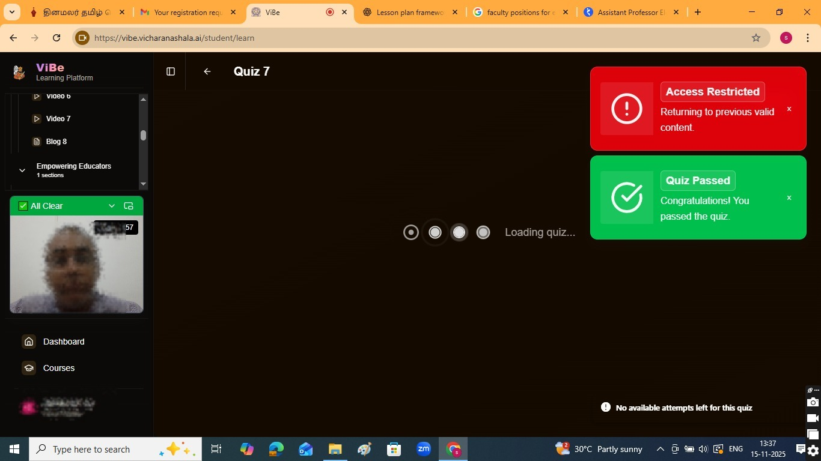
This issue can be faced due to several reasons you can do the following steps to overcome it:
- Refresh the page using Ctrl+R.
- You can logout and login again.
- Your total permitted attempts for this quiz may have been exhausted. Please review the segment again before attempting the quiz once more.
- If even after then you are facing the same issue then please contact our support desk via email or message, providing your name, registered email ID, and either a screenshot or a screen recording of the problem.
__

16. Why do my videos auto-restarts?
The videos can auto restart due to the following reasons:
- Face not being detected.
- Blur background
- Background noise being detected.
- Face is not visible.
- More than one person in the camera is being detected.

17. Why is the quiz not opening even after completing the video segment?
- You can log out and log in again.
- Share your query in the Support desk email support-cbpai@vicharanashala.zohodesk.in with detailed screen shot or screen recording.

